­­­­­­Data in this folder are:

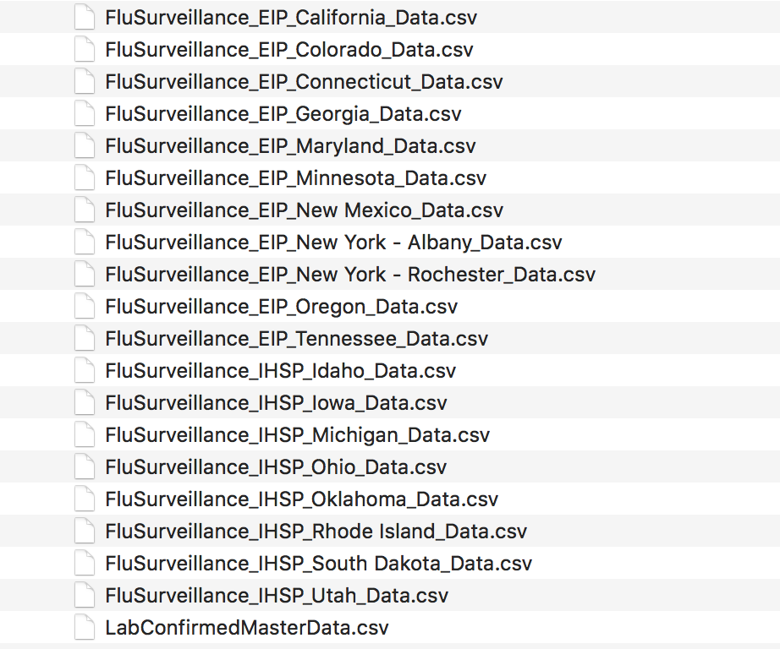

All the data sets in this folder are collected between the flu season of 2003-04 to 2019-20.

All of the data sets are downloaded from the Flu Hospitalization Rates interactive application accessible through the following URL: <https://gis.cdc.gov/GRASP/Fluview/FluHospRates.html> (For the method and purpose of this dashboard, pleasevisit: <http://www.cdc.gov/flu/weekly/overview.htm#Viral>). Data from the 10 Emerging Infections Program (EIP) states (CA, CO, CT, GA, MD, MN, NM, NY, OR, and TN) and additional Influenza Hospitalization Surveillance Project (IHSP) states are combined into a master data set named as LabConfirmedMasterData.csv. Variables in this data set are listed below:

|  |  |  |
| --- | --- | --- |
| File | Variable | Note |
| LabConfirmedMasterData.csv | CATCHMENT | Names of state |
|  | NETWORK | EIP or IHSP |
|  | SEASON | From 2003-04 to 2019-20 |
|  | MMWR-YEAR |  |
|  | MMWR-WEEK |  |
|  | AGE CATEGORY |  |
|  | CUMULATIVE RATE |  |
|  | WEEKLY RATE |  |

There are 19 States in total participated in EIP or IHSP:

California

Colorado

Connecticut

Georgia

Maryland

Minnesota

New Mexico

New York - Albany

New York - Rochester

Oregon

Tennessee

Idaho

Iowa

Michigan

Ohio

Oklahoma

Rhode Island

South Dakota

Utah

For more information, please read the following text or visit <http://www.cdc.gov/flu/weekly/overview.htm#Viral>.

Laboratory confirmed influenza-associated hospitalizations in children and adults are monitored through the Influenza Hospitalization Surveillance Network (FluSurv-NET). FluSurv-NET conducts population-based surveillance for laboratory-confirmed influenza-related hospitalizations in children younger than 18 years of age (since the 2003-2004 influenza season) and adults (since the 2005-2006 influenza season). The network includes more than 70 counties in the 10 Emerging Infections Program (EIP) states (CA, CO, CT, GA, MD, MN, NM, NY, OR, and TN) and additional Influenza Hospitalization Surveillance Project (IHSP) states. The IHSP began during the 2009-2010 season to enhance surveillance during the 2009 H1N1 pandemic. IHSP sites included IA, ID, MI, OK and SD during the 2009-2010 season; ID, MI, OH, OK, RI, and UT during the 2010-2011 season; MI, OH, RI, and UT during the 2011-2012 season; IA, MI, OH, RI, and UT during the 2012-2013 season; and MI, OH, and UT during the 2013-2014 through 2019-20 seasons.

Cases are identified by reviewing hospital laboratory and admission databases and infection control logs for patients hospitalized during the influenza season with a documented positive influenza test (i.e., viral culture, direct/indirect fluorescent antibody assay (DFA/IFA), rapid influenza diagnostic test (RIDT), or molecular assays including reverse transcription-polymerase chain reaction (RT-PCR)). Data gathered are used to estimate age-specific hospitalization rates on a weekly basis and describe characteristics of persons hospitalized with influenza illness. The rates provided are likely to be an underestimate as influenza-related hospitalizations can be missed if testing is not performed.

Patient charts are reviewed to determine if any of the following categories of high-risk medical conditions are recorded in the chart at the time of hospitalization:

* Asthma/reactive airway disease;
* Blood disorder/hemoglobinopathy;
* Cardiovascular disease;
* Chronic lung disease;
* Chronic metabolic disease;
* Gastrointestinal/liver disease;
* Immunocompromised condition;
* Neurologic disorder;
* Neuromuscular disorder;
* Obesity;
* Pregnancy status;
* Prematurity (pediatric cases only);
* Renal disease; and
* Rheumatologic/autoimmune/inflammatory conditions.

During the 2017-18 season, seven FluSurv-NET sites (CA, GA, MN, NM, NYA, OH, OR) conducted random sampling to select cases ≥50 years for medical chart abstraction, while still performing full chart abstractions of all cases <50 years. During the 2018-19 season, six sites (CA, GA, NM, NYA, OH, OR) conducted random sampling of cases ≥65 years for medical chart abstraction. All other sites performed full chart abstractions on all cases. Data on age, sex, admission date, in-hospital death, and influenza test results were collected for all cases. For each season going forward, including 2019-20, sampling for medical chart abstraction may be considered in cases ≥50 years. In early January of each season, observed case counts across all FluSurv-NET sites will be compared against predetermined thresholds to determine whether sampling will be implemented for the season.

Additional FluSurv-NET data including [hospitalization rates for multiple seasons and different age groups](https://gis.cdc.gov/GRASP/Fluview/FluHospRates.html) and [data on patient characteristics (such as virus, type, demographic, and clinical information)](https://gis.cdc.gov/grasp/fluview/FluHospChars.html) are available on FluView Interactive.